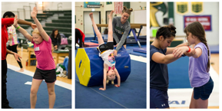
Day 4 - Wednesday - June 27th

Camp Abilities News
  - “Believe you can achieve”
Rain, rain - go away! Our athletes want to run and play! Swim and play! In spite of the on-off showers, we had a busy day of activities. |  | Reminder to families and friends: visit us on Facebook for more photos and stories.
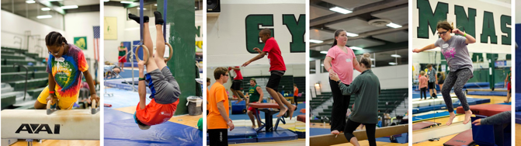
Care to share!
Morning and Evening Report

Jaylyn: caught a fish.
Chantal: excited to practice aerial in gymnastics.
Keara: rode a single bike for the first time. Swam 8 laps.
Lt. Dan: didn’t fall at Stand-up paddle board, forward and backward rolls in gymnastics, perfect 10’s in Showdown vertical.
Abby: goal was not to fall of the paddle board! Now an officer for Brockport PD - thanks to Lt. Dan.
Faith: played with Jeff Mann drums, vertical showdown.
Kiana: caught a fish, swam 4 laps, ran 1 mile in 13:37.
Andrew: made 2 side shots in basketball.
Adam: had fun at drums with Jeff last evening.
Quenton: caught 3 fish.
Makenzie: can’t wait for gymnastics, went fishing.
Braiden: all 9 components for ECC, had a lot of fun during drums, excited for gymnastics.
Leah: caught a fish, did smiley grams.
Meghan: in beep baseball ran to base in 5 seconds.
Makenzie: met goal on balance beam.
Chantal: fell off paddle board only once, learned new moves in yoga gymnastics, straddled off of the balance beam.
Meghan: did the splash-splash slide on paddle board and did not fall off, in gymnastics did a flip off the bar.
Chris: made a goal in goal ball.
Keara: splash-splash slide on paddle board, 20 laps on the tandem bike, vaulted into pit.
Braiden: walked on high balance beam alone, “Sally-up & Sally-down” song for fitness.
Kiana: tandem bike 20 laps = 4 miles, in gymnastics vaulted into pit, hung from the bar.
Mina: back flip off the bar.
Anneka: tandem bike 6 miles, paddle board tree pose held for 4 seconds, gymnastics vaulted into pit for the first time, high balance beam walked backwards and forwards.
Dan: Field & Track ran the 25 meters.
Bryce: gymnastics balanced on high beam without help. And mastered the cartwheel.
Faith: ran 50’ in 11 seconds, hit a live pitch in beep baseball.
Kat: did not fall off the stand-up paddle board.
Abbey: gymnastics tried the rings and weights in fitness. Had fun.
Leah: 8 laps in swimming.
Taylor: hit a live pitch in beep baseball.
Laura: paddle board fell in water 3 times but completed the splash-splash slide.
Angelina: 20 laps in swimming and threw a curve ball in goal ball.
Henry: completed the 100-meter dash 1 second more than his record time.
Austin: backstroke for 28 seconds length of the pool and swam 20 laps.
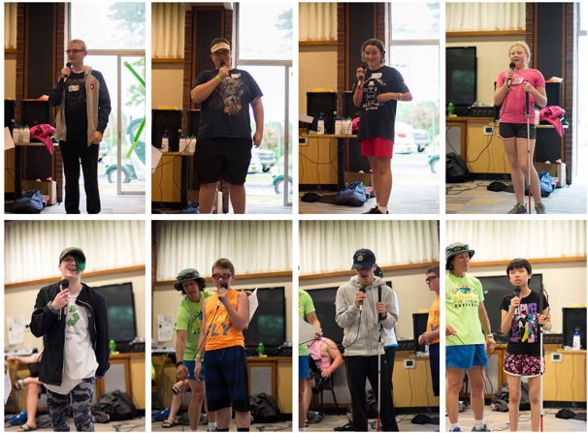

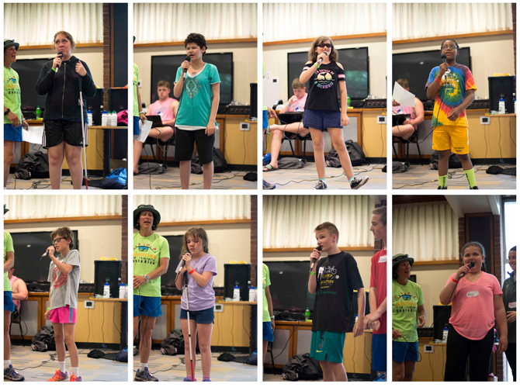

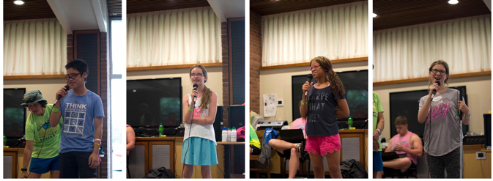

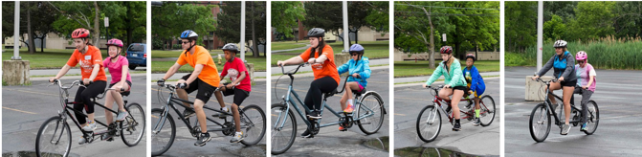

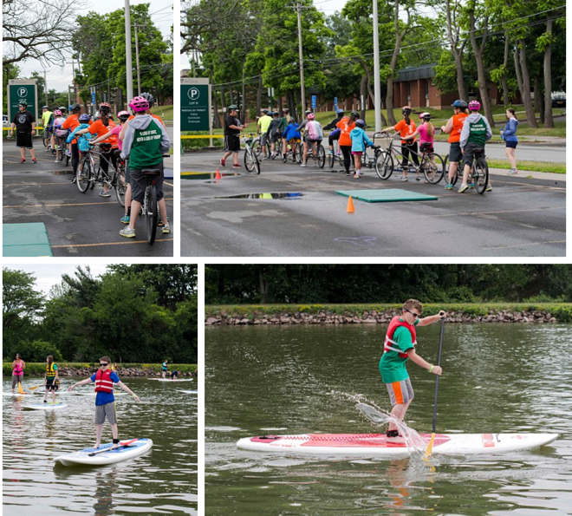

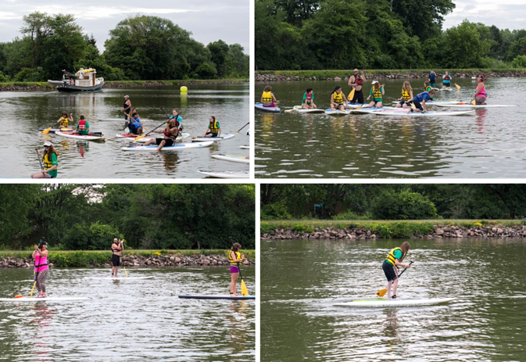

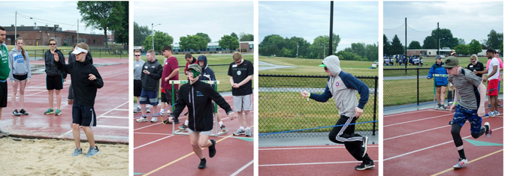

Ronan and the soda can tabs:
Ronan gave Stan (Dr. Lieberman’s father) a bag full of soda can tabs he collected for nearly 2 years. The tabs will be turned into West Chester Senior Center, PA. which then sends them to the Ronald McDonald House. Thank you, Ronan!
